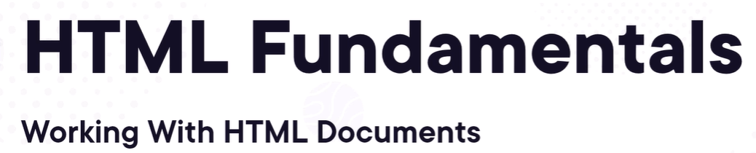
Welcome to this module on HTML fundamentals where we'll
talk about working with HTML documents.
In this particular module, we're going to start by looking at what HTML is,
help you understand it at its core before we really dig into how to build it,
how to use it to make great web pages. We're going to look
at how browsers use the HTML that you write in order to
render those great webpages.
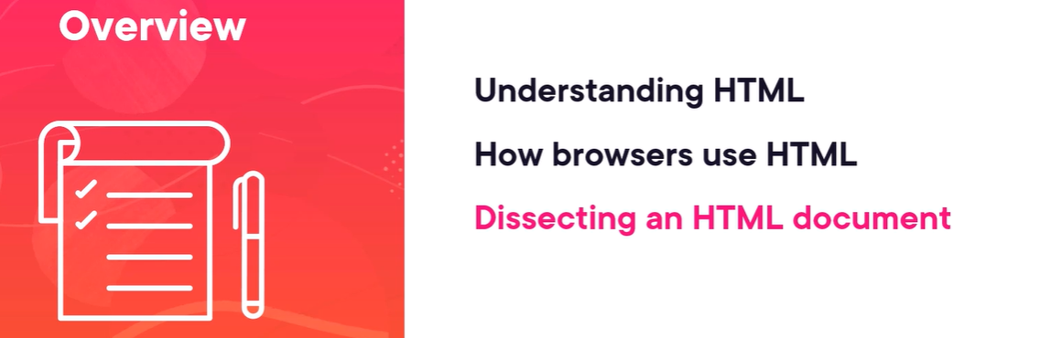
What do they see versus what the user sees?
We're going to dig into the different components of an HTML document,
both the kind of metadata or extra data about the content,
as well as how to present the content.

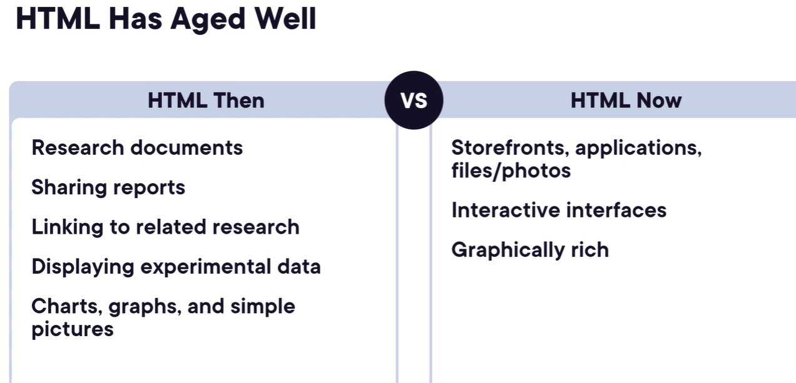
HTML has been around now for decades, and it's aged very well.
While the original purposes have changed for how we use it today,
it's been able to adapt and grow to meet those needs.
When HTML was created,
it was really about academics and researchers wanting to
share their research documents with others.
They wanted to share reports,
they wanted to link to other research so it was very easy to be looking
at one research document and then open another one,
display some data, what are your results, what were your
different test cases, and maybe some charts,
graphs and simple pictures about their research.
But today we're building storefronts, applications,
file and photo sharing, interactive interfaces that light up and let
you do things that you used to only be able to do with desktop
applications, and they're graphically rich.
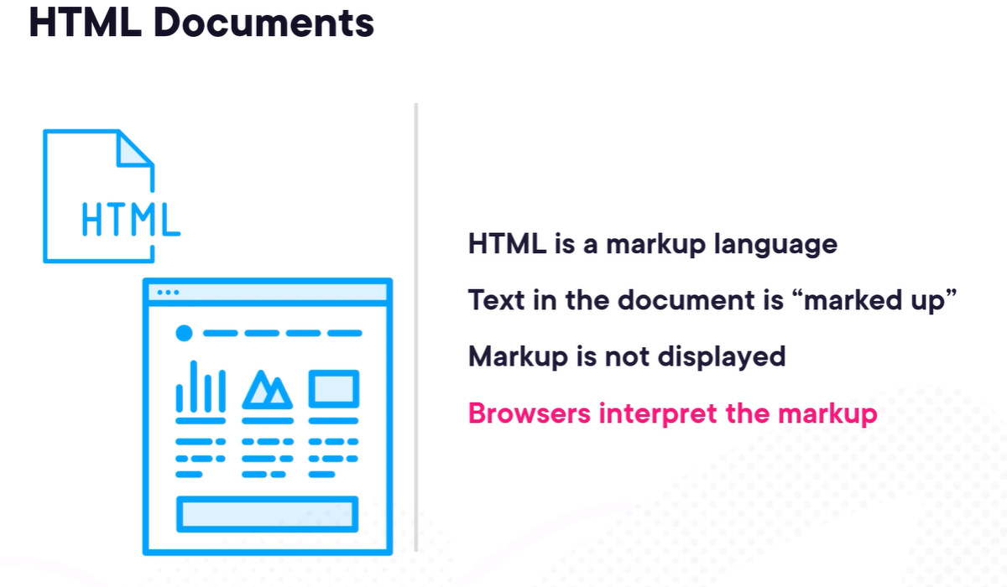
But those fundamental concepts have stayed the same.
It may look drastically different because we had a lot of plaintext,
and we had some links, as you can see, citations,
maybe some numbered lists, and some titles or headings.
And today, while this looks vastly different,
when I look at it and think about HTML,
I still see lists, I still see links to other items, and text,
but it's got richer formatting, more colorful,
lots of images, and a lot of interactive components
that weren't there at the beginning.
But again,
that HTML specification, that fundamental technology, has
been able to adapt and grow to handle that. HTML is a
language that we use to create documents.
This is going to have content that we want to generally present to
someone. And HTML is what's known as a markup language.
And that means we're going to have content or text in a
document just like we would in a word processing document,
like Word. And we're going to mark it up.
We're going to add additional information around certain elements in
that document in order to change how they're processed or how they're
viewed. That markup, that extra information that we provide, isn't
generally displayed on a particular page,
but it's used to perhaps change how the other text is
displayed or how we interact with it.
I'll probably use the term browser and client interchangeably in
this course because browsers are the most common client for
consuming HTML documents, but they're not the only one. But those
browsers interpret that markup.
They look at the whole HTML document and their job then is to render
the output, maybe with all of those great images,
colors, fonts, and interactivity.
We have these HTML documents, then, HTML standing for hypertext markup language.
We also talk about hyperlinks,
this ability to link things together from one document to another.
But that HTML, or that markup language, is a specification
that defines how we create those documents to be consumed
by the browsers or clients.
In order to work with those documents,
we need to be able to request them and receive them.
And that's where HTTP, or the hypertext transfer protocol, comes into play.
This is how your browser reaches out to a particular web server, says I
would like this particular page and gets the data back, or I'm adding
content into a form and I'm submitting it so I want to send that data back
to the web server. That's a whole different specification, then, for the
transport or the interaction between the client and the server that are
exchanging this HTML.
And then we have two related concepts that you'll hear. One
is a URI, or uniform resource identifier, and that's really
a unique name for a resource.
And a resource can be a web page,
but it could also be a data endpoint or an endpoint in a
service that isn't going to return HTML.
It might return something called JSON, JavaScript Object
Notation, or XML, a different markup language,
both typically used more in programming languages rather than in display.
So that identifier identifies a particular resource, and a subset of URIs
is what's known as a uniform resource locator, or URL.
And you're probably familiar with these, going into your browser and typing
in a web address to get somewhere or get a particular document. When you save
a bookmark or a favorite in your browser, what you're saving is a name that
goes along with a URL for where that particular page or HTML document is that
you want to go back to.
So that uniform resource locator has a unique name that makes it URI,
but it's also something you can use to go and get or
interact with that particular resource,
which means it has the protocol like HTTP, HTTPS, as the servers
and ports and the path to an actual document.
So these are all terms you're going to hear and that we'll use as we interact with our pages throughout the course.
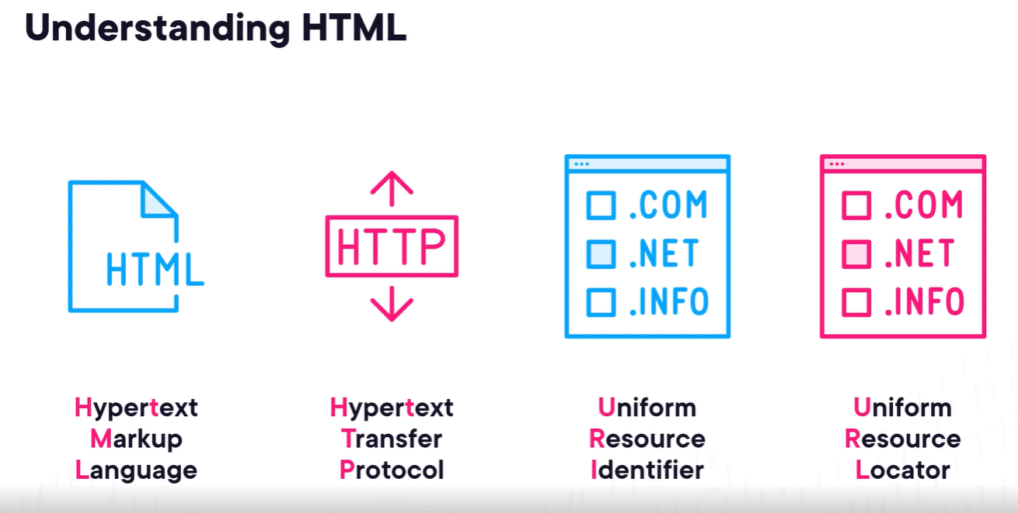

HTML Document
Let's dive in then to how do we create an HTML document?
The first part of the document, the very first thing you're going to see is what's called a DOCTYPE.
And this is what's known as processing instruction.
You can see two different examples here.
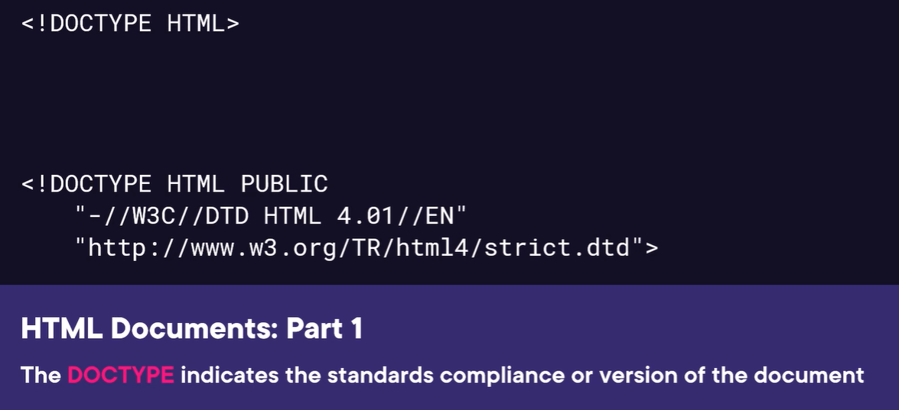
They both start with that sign less than sign and then an exclamation mark, a DOCTYPE declaration, and then a particular type.
The first one, being very simple, just says HTML, and then it closes out with a greater than sign.
This is what you're going to see in most cases is this very simple example.
I hope you don't have to see the second example because that means you're working with some old web pages.
These have changed over time, but again, you'll see that we typically are going to just use a DOCTYPE of HTML.
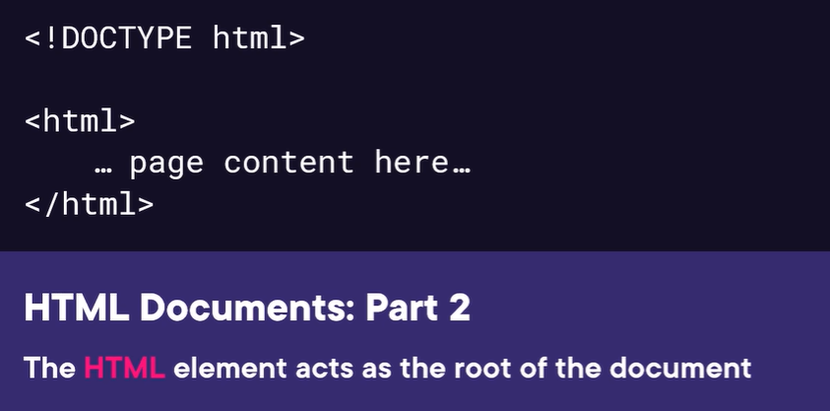
The next thing you're going to see is the HTML element. So these items inside the greater than/less than sign, or referred to as angle brackets, that's known as an element.
That's the markup.
So here we have the first item, we say this is the HTML in this page, and we must have one of those at the top level here, and we'll see we're going to nest some things inside of there to build out the full document, but that's what's known as the root of the document, the starting point so that the client knows where to start processing.
So, we've got the standard, we've got the root element, and then we have the head element.
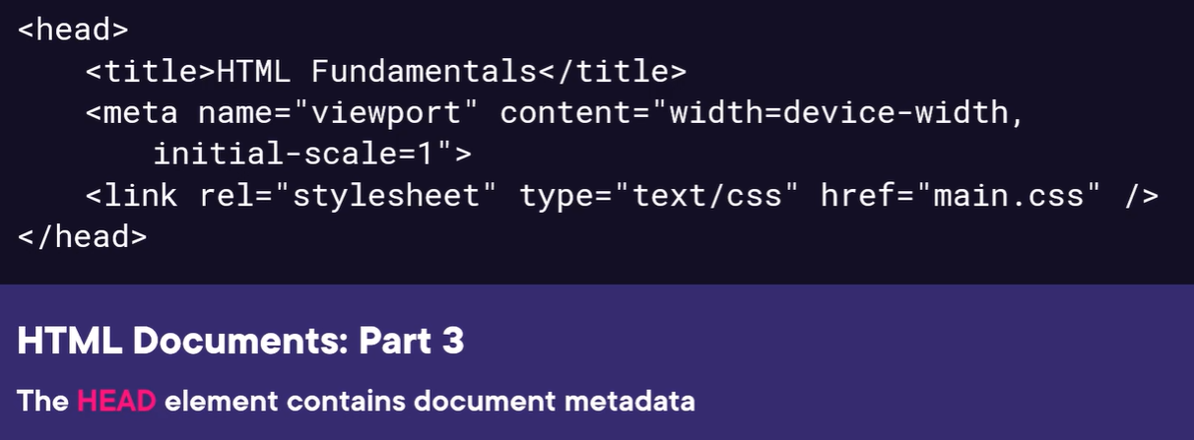
The head really contains metadata about your web page or your HTML document.
Most of this isn't going to be displayed anywhere. The things that you add here may impact the display, but it's really what we call metadata about the document itself.
So, you can see, I have a title here. I have a meta element that has some information in there.
I have a link to a style sheet. And we'll talk about all these specific details, but this isn't really the content of my document.
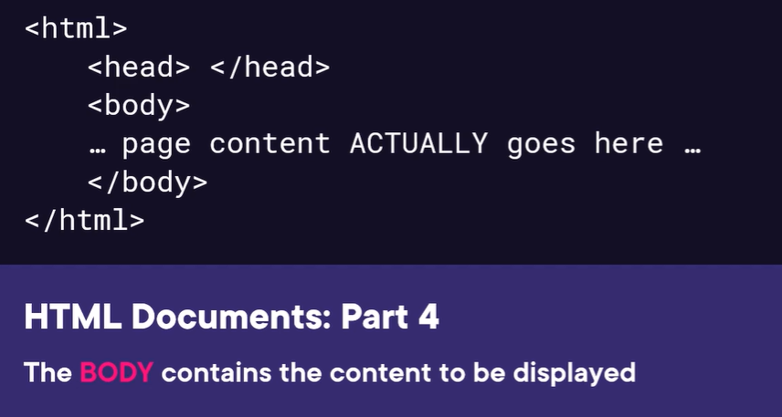
Then we get to the body. The body is really where that content is. This is where our text, our images, our tables of data, those sorts of things are going to be presented, and that's the bulk
of what you'll actually see in your browser client.
So that's our skeleton, the HTML, the head, and the body. Let's take a look at some examples of working with an H TML document.

An HTML Document (DEMO)
Let's now go and build an HTML document and take a look at it. 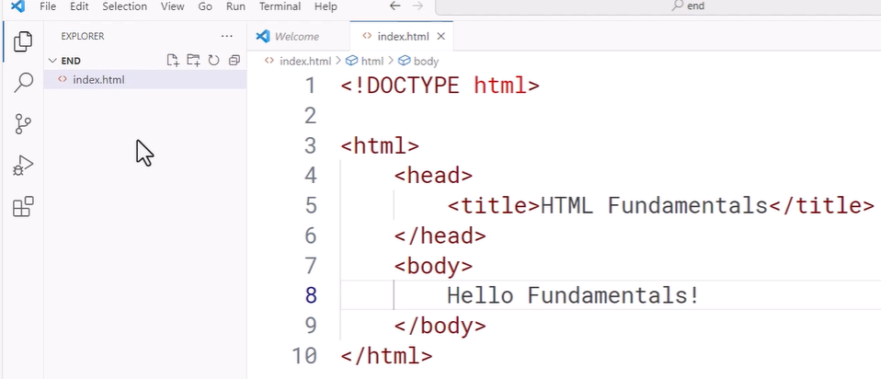
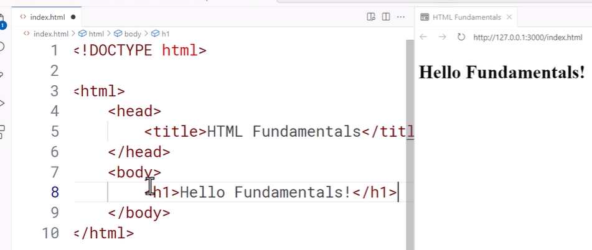

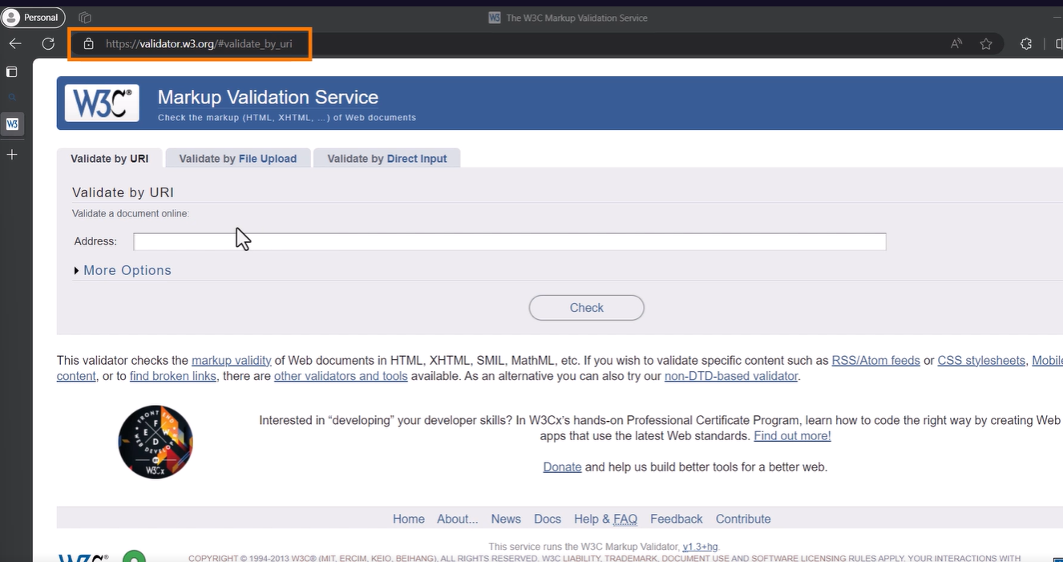
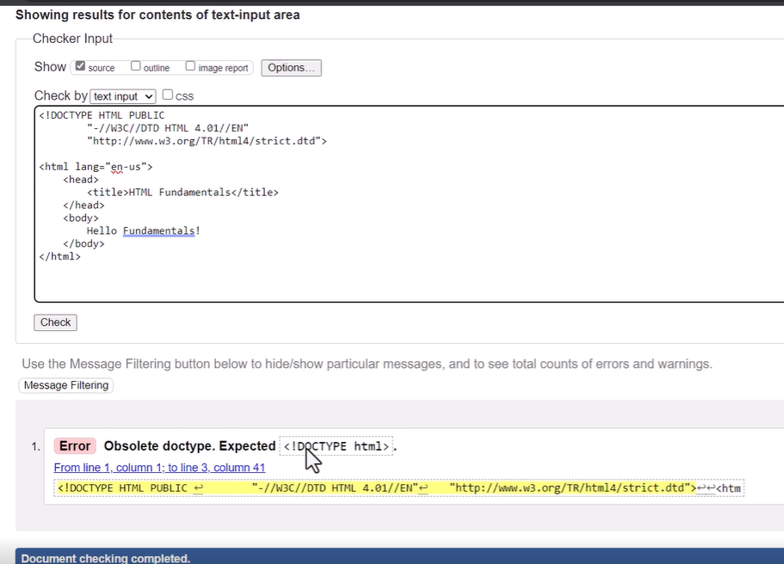

The Head Element
I want to spend a little more time on the head and the different elements that you might find in there. We saw the <title>, and this is really the main piece of metadata where we
say this is the title of the page.
It's often displayed in the title bar of the actual browser. So in your tab, so it identifies the page for people. Now, if you have 50 or 60 tabs open, you may not see that title, but that's the goal is to help you identify that page and know what it is. Those <meta> elements are, again, we're in the head, it's metadata, this is metadata, it can contain information about presenting the page. For example, we saw the viewport, which can identify how it should render the page based on whether it's on, for example, a mobile device or a desktop.
It can have additional keywords and information.
And decades ago, it was how you would provide information to search engines, but people gamed that system and now that's not a standard practice to put information in there to help with search.
The <script> element is how you can include script directly into the web page. And the script will be JavaScript, and that allows us to add that interactivity into the page.
So we can create script that reacts when somebody clicks on a button or clicks on an image. We can have it set up on a timer so that it runs periodically to update the page or do changes or even call out for data from some external source. The <style> element allows you to declare styles right inside your page. And this is how we change the look and feel or the visual display of elements. Styles can be everything from coloring, fonts, alignment, layout, sizes, positioning.
They are are a very rich way to change how the content is displayed. So the HTML itself will have your content, will have your article, your research document, your product detail page, and the styles are really going to help you control how that looks to the user.
We've got <link>. Now, <link> is linking some other content into the processing of your HTML page. A common reason for that is, for example, to pull in styles.
So you don't define them in every single page, you define them in a separate file and you link those into your document. So that tells the browser when you're going to process my HTML, you should pull in this other content and use it as part of that processing,
apply those styles, for example.
And we have <base>.
This tells the browser that for any links on your page where
you're going to link to other content, either in the page or in other pages,
that this is the base address to use from which all
of those links will be relative.
So you can use this if you want to have one place on the
page where you identify that base address,
maybe back to the same server or a different server,
and then you don't have to reference it and all of the links throughout your page.


